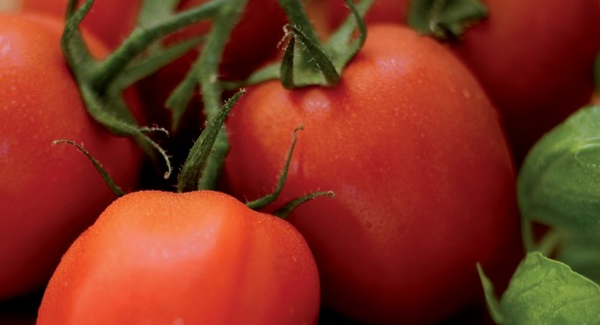
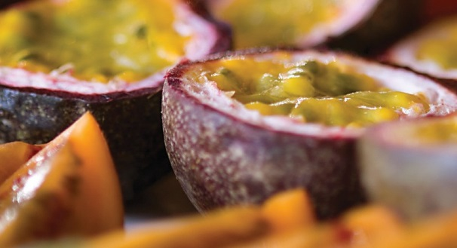
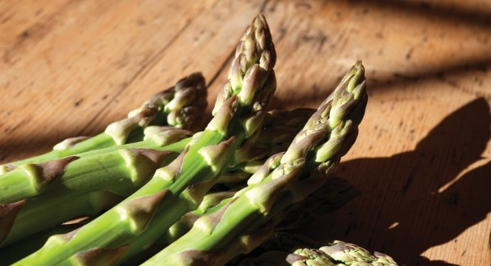



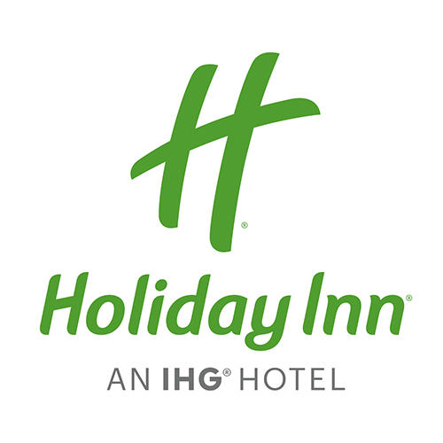

£8.50 per person

Selection of Sandwiches

Egg Mayonnaise & Cress*
Tuna Mayonnaise with Cucumber
Savoury Cheddar with Pickle*
Home Baked Ham & Tomato

**Gluten Free Bread Available on Request**

Salads
Dressed Garden Salad*

Sides
French Fries*

Served with a selection of dips



^ NGCI * Denotes suitable for vegetarian. We welcome enquiries from customers who wish to know whether any meals contain particular allergens.

